**PyCitySchools Analysis**

**Part I - District Summary :**

* There are 15 schools in total and 39,170 students in total
* Total budget amongst all of the schools is $24,649,428.00
* Average score for math is 74.98%
* Average score for reading is 85.80%
* 65.17% of students passed both math and reading



**Part II - School Summary :**

* Budgets of schools vary from just over $3.1m to slightly below $250k
* Baily High School has the largest budget ($3,124,928.00)
* Holden High School has the smallest budget ($1,049,400.00)

**Part III - Highest & Lowest Performing Schools (by % Overall Passing) :**

* Cabrera High School is the highest performing school
  + % Overall Passing = 91.34%
* Rodriguez High School is the lowest performing school
  + % Overall Passing = 52.99%

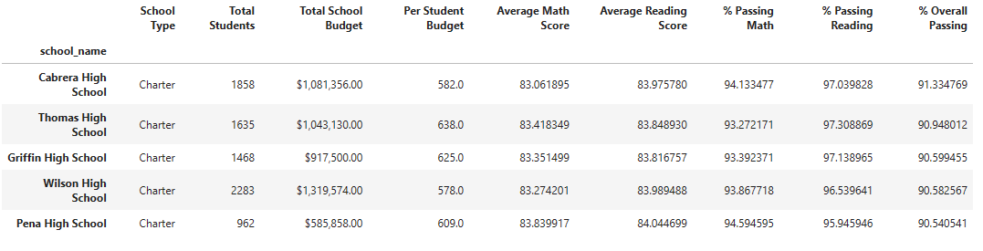

**Part IV - Math & Reading Scores by Grade :**

* No patterns identified from the average scores per grade for both math and reading

**Math Scores Reading Scores**

**Part V - Scores by School Spending :**

* Based of this dataset, the less money spent per student resulted in better math, reading, & overall passing rates

**Part VI - Scores by School Size :**

* No patterns or notable differences between small and medium sized schools
* Larger schools have lower math scores and have a significantly lower pass rate for math, reading, and overall
  + Note: larger difference between passing math values between small/medium schools and large schools

**Part VII - Scores by School Type :**

* Charter Schools perform at a much higher rate than District Schools
* >90% of students are passing at Charter Schools pass both math and reading
* ~65% of students for passing math scores and ~80% for passing reading scores for District Schools.

